Aloisia presentation Note ---

Manufacturing of 3D-printed morphing origami

...

Polymers Dispersed liquid Crystals PDLC

(ultimaker-printed)

-- deployment done

PDLC and thermal heating

Ikaros Spinning,

L-Garde solar sail

Boom deployment

Materials round-up:

Aluminized membrane (Highly reflective)

Reflective control devices for ACOM

flecible and thin solar cells

The RCDs user variable transmittance materials

Indium Thin Oxide (ITO) as transparent conductive electrode (TCE) - It doesn't block light when using it for circuitry. The more it is bent the less useful it is.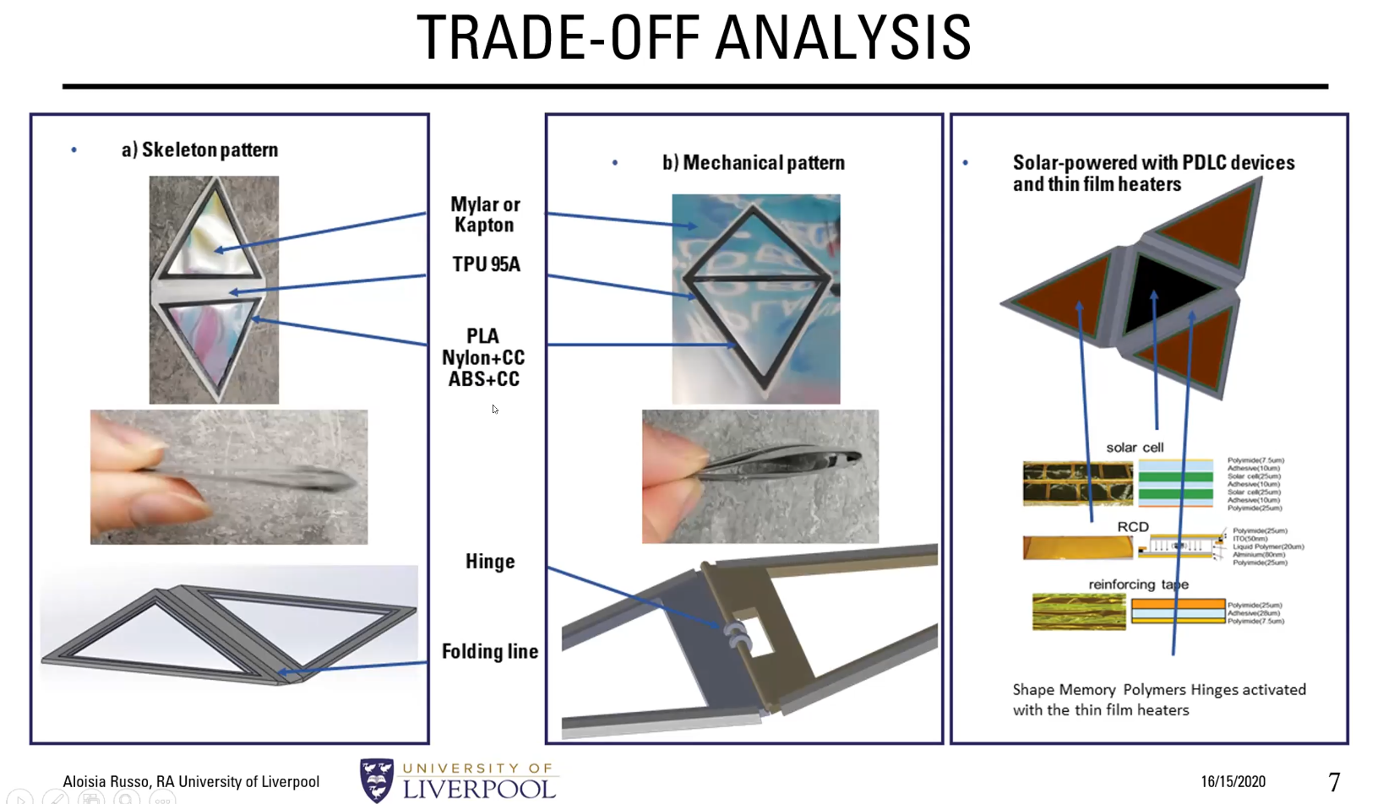

Other designs have been considered as pictured above,

Aloisia made compatibility tests with glue, with several materials

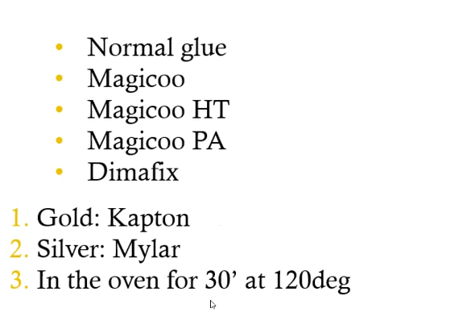

Materials had wrinkles at ambient temperature in the lab, however they went away as the device “colded down” (thermal contraction of the material?)

Value of K’s calculated:

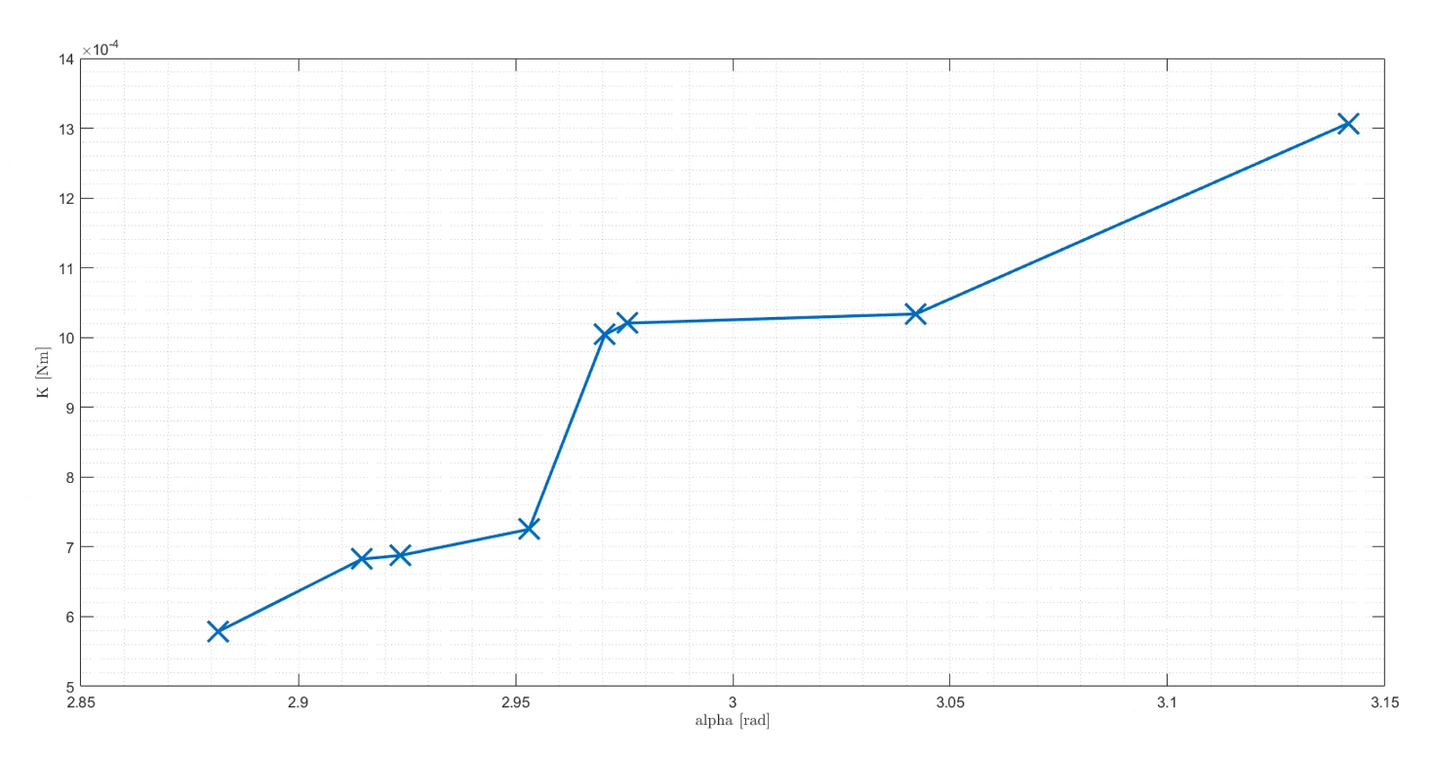

The expansion from pyramid mode can be made by heating the elements, but because of lack of this, it can be done by heating the crinkles with current.

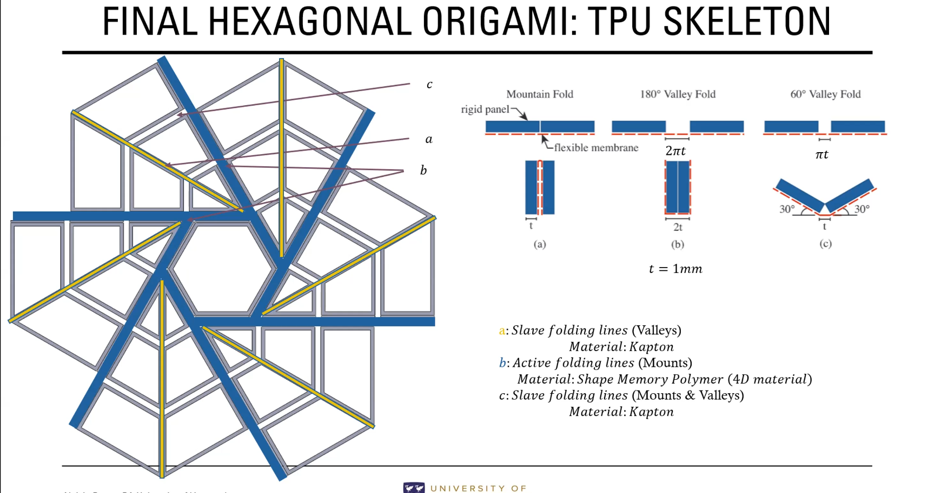

ABS

TPU98: high energy particle radiation might be a problem.

Wrinkles: Occur at temperature difference, difference on .

Experiments used a heater fan. (Red lamp testing?)

50 degrees filament provides this expansion.

Materials done specially for space

Bonar Robb Glasgow 1:15:00

Only specular reflection, done by ray tracing,

Rays that bounce off one panel and hit another can accelerate deployment

How can this experiments be simulated in real life?

0-G plane trip

Vacuum?

Lamp?

* It could be possible to control the reflectivity of the panels to coordinate deployment shapes.